
FRENCH:
YEAR 5
KNOWLEDGE ORGANISER
Food and Drink |  |  | Classroom language and useful phrases when at a café/restaurant
 |  |  |   Voilà
  une orange- range  une banane – banana  une carotte – carrot  du pain – bread  du boeuf – beef  du fromage – cheese  du poisson – fish  du poulet – chicken  des oeufs – eggs  du riz – rice  de la laitue/salade - lettuce |  | 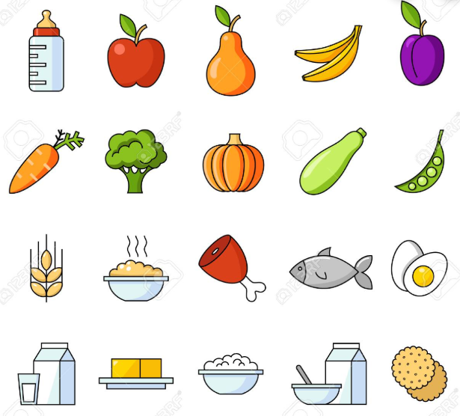 | un jus d’orange – orange Juice  un jus de pomme – apple juice  un café – coffee  du lait – milk  du thé – tea  de l’eau – water  du coca – coke  de la limonade – lemonade
  How do you say [.........] in French / English? | Comment dit-on [.........] en français/anglais?
  I don’t understand. | Je ne comprends pas.
  Can I help? | Je peux aider?
  I have a question. | J’ai une question.
  I have forgotten [.........] my pen.  my pencil case. | J’ai oublié [.........] mon stylo.  ma trousse.
  Do you have a glue stick? | Avez-vous un bâton de colle?
  I don‘t know. | Je ne sais pas.
  Can I open the window? | Est-ce que je peux ouvrir la fenêtre?
  I would like | Je voudrais
  There you are | Voilà
  Can I have the bill please | L’addition s’il vous plaît
Transport |  |  | Adjectives
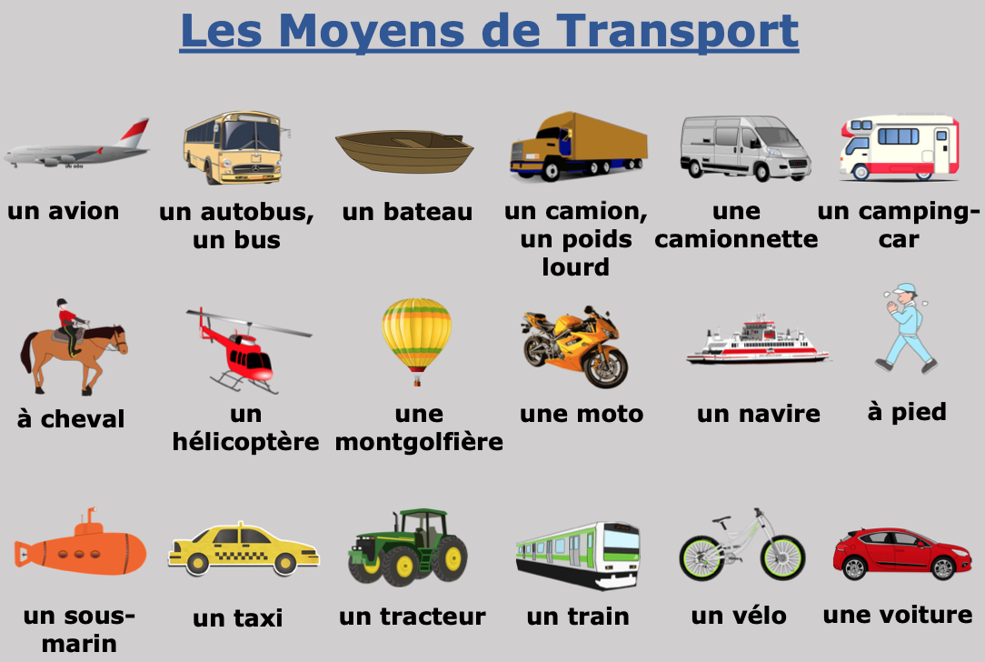 |  |  | Masculine  petit – small  grand – big/tall  jeune – young  vieux – old  gentil – kind  bon – good  facile - easy  intelligent – intelligent  beau – handsome  fort - strong | Feminine  petite – small  grande – big/tall  jeune – young  vieille – old  gentille – kind  bonne – good  facile - easy  intelligente – intelligent  belle – beautiful  forte - strong | Adjectives Rules!  -Most French adjectives are placed after the noun (the word that they describe).  -The only adjectives that do not do this are the BANGS adjectives (adjectives about beauty, age, number, goodness, or size).  -Spelling of French adjectives can change depending on the number and gender of the noun that they describe.  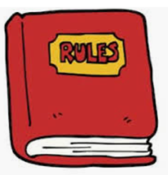
,
zéro cinq dix quinze vingt vingt-cinq trente trente-cinq quarante quarante-cinq cinquante cinquante-cinq soixante
0 5 10 15 20 25 30 35 40 45 50 55 60
5 Times Table

